Fabric Capacity Policies
Deployment guide
Version 1.0 - 14 October 2026
Contents

Scope of this document
This guide is the single procedure for deploying the Fabric Capacity Policies solution to a new Power Platform environment: what has to exist first, what is created, imported, set and switched on, in which order, and how to prove it works before handing over. It brings together the deployment steps, the ALM notes, the identity requirements and the table build in one place.
It stops where the cutover starts. Bringing an existing estate under policy is covered by the Migration guide; day-to-day operation and failure handling by the Error handling and monitoring guide.
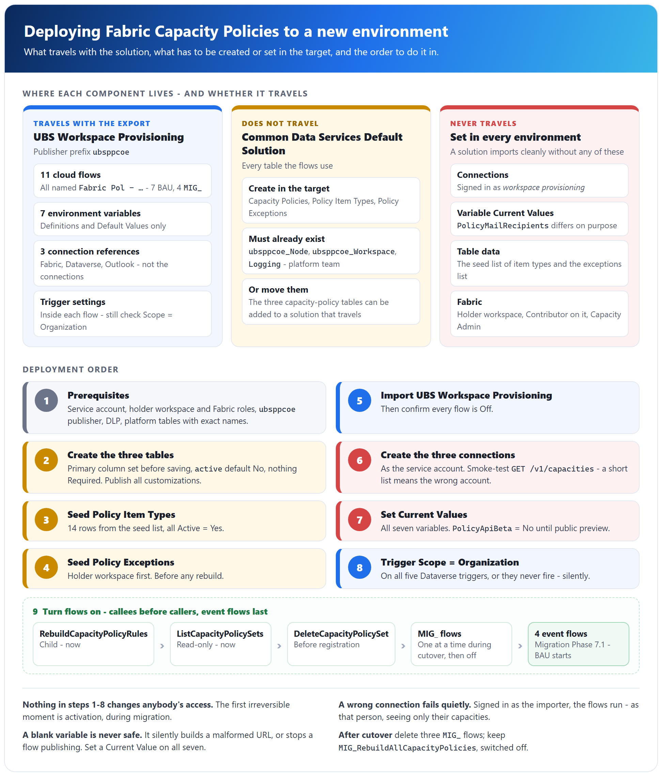

1. What gets deployed

1.1 Where each component lives
The solution is split across two Power Platform solutions in the same environment, plus objects outside Power Platform. Where a component lives decides whether it travels with an export, so this table is the starting point for every deployment.
Component | Count | Lives in | Owner
Cloud flows, every display name starting Fabric Pol - | 11 - 7 BAU, 4 MIG_ | UBS Workspace Provisioning (publisher prefix ubsppcoe) | This project
Environment variables | 7 | UBS Workspace Provisioning | This project
Connection references - Fabric, Dataverse, Outlook | 3 | UBS Workspace Provisioning | This project
Capacity Policies, Policy Item Types, Policy Exceptions | 3 tables | Common Data Services Default Solution | This project
ubsppcoe_Node, ubsppcoe_Workspace, Logging | 3 tables | Common Data Services Default Solution | Platform team
Holder workspace - holds every policy set | 1 | Fabric | This project
Seed data - the seed list of item types and the exceptions list | 2 | Steps 3 and 4 of this guide | This project
The flows are:
Group | Flows | Trigger
BAU - event | Fabric Pol - InitializeCapacityPolicySet, Fabric Pol - DeleteCapacityPolicySet, Fabric Pol - AddWorkspaceToPolicy, Fabric Pol - RemoveWorkspaceFromPolicy, Fabric Pol - RebuildOnExceptionChange | Dataverse row change
BAU - child | Fabric Pol - RebuildCapacityPolicyRules | Manual, called by the flows above
BAU - helper | Fabric Pol - ListCapacityPolicySets | Power Apps (V2), called by an app outside the solution
Migration | Fabric Pol - MIG_RegisterAllCapacityPolicySets, Fabric Pol - MIG_InitializeCapacityPolicySet, Fabric Pol - MIG_RebuildAllCapacityPolicies, Fabric Pol - MIG_ActivateAllCapacityPolicySets | Manual
There is no custom connector. Fabric is called through the built-in HTTP with Microsoft Entra ID (preauthorized) connector, so there is no connector definition, app registration or client secret to deploy.

1.2 What travels with the solution and what does not
Exporting UBS Workspace Provisioning carries no table. All six tables live in the Default Solution, so the three capacity-policy tables must be created in the target - or added to a solution that travels - before the flows are imported or run.
Travels in UBS Workspace Provisioning | Does not travel - create, set or grant in every environment
Flow definitions, including trigger settings | The three capacity-policy tables - they are in the Default Solution
Environment variable definitions and Default Values | Environment variable Current Values
Connection references | Connections - created and signed in again as the service account
 | Table data - both hand-maintained tables need seeding
 | The holder workspace, and the Fabric roles on it and on every capacity
 | The platform team's tables and their data
The two that catch people are environment variable values and connections. A solution imports cleanly with neither, and the flows then fail at runtime - or, worse, run as the wrong person. See section 6.

2. Prerequisites
Everything in this section must be true before step 1 of section 3. None of it changes anybody's access, and every item is cheaper to find missing now than during the first rebuild. Why each identity and permission is needed is explained in the Architecture document, section 6.

2.1 Identity - the service account
One identity is used everywhere: the workspace provisioning service account. It is a user account with email and password, not a service principal, and every Fabric and Dataverse call is delegated as that account.
# | Requirement | Why
I1 | A user account - the workspace provisioning service account | All three connections sign in as it
I2 | Licensed for Power Automate and Dataverse | A connection needs the account to stay licensed
I3 | Exempt from password expiry and interactive MFA, or a documented re-authentication process | A rotation silently breaks every Fabric call until the connection is re-authorised
I4 | Not blocked by a Conditional Access policy | Same failure - 401 on every capacity at once
I5 | Excluded from joiner-mover-leaver reviews | Service accounts do get disabled by lifecycle automation

2.2 Fabric
# | Requirement | Note
F1 | A holder workspace exists | One workspace holds every policy set in the tenant. Put it on an ungoverned capacity if you can - otherwise it needs an exception row (step 4)
F2 | Service account is Contributor (or Admin) on the holder workspace | Needed to create and update policy sets. On no other workspace
F3 | Service account is Capacity Admin on every capacity to be governed | Needed to activate, and to see the capacity in GET /v1/capacities. Repeat for every new capacity, for ever
F4 | Governed capacities are F SKU and Active | P, A, EM and PP SKUs cannot hold a policy set
The account deliberately needs nothing else - no role on the governed workspaces and not Fabric Administrator. Workspaces appear only as values inside rules.

2.3 Entra ID and tenant settings
# | Requirement
E1 | No app registration, client secret or API permission to configure - the identity is a user
E2 | No Fabric tenant setting needs changing. The API-gating settings apply to service principals only
E3 | Admin consent for the HTTP with Microsoft Entra ID (preauthorized) connector, if user consent to applications is disabled in the tenant. One-off, needs a tenant administrator

2.4 Power Platform and Dataverse
# | Requirement | Note
P1 | A target environment with Dataverse
P2 | The publisher with prefix ubsppcoe exists | It owns ubsppcoe_Workspace, so it already exists. Reuse it; never create one with another prefix - every logical name the flows use would be wrong
P3 | DLP policy puts HTTP with Microsoft Entra ID (preauthorized), Microsoft Dataverse and Office 365 Outlook in the same data group | Otherwise the flows will not save or run
P4 | The person deploying holds System Customizer or System Administrator | Needed to create tables and import
P5 | The platform team's tables exist with the exact names below | Stop if they do not. A renamed column does not error - the filter returns nothing and the capacity silently locks down
P6 | A Dataverse security role for the service account, at Organization depth | Privileges below
The platform team's tables and the columns this solution depends on (the names that cause the most mistakes are explained in the Architecture document, section 7.4):
Table | Columns that must exist
ubsppcoe_Workspace | ubsppcoe_workspaceuniqueid (row key), ubsppcoe_workspaceid (Fabric workspace GUID, Unique identifier), ubsppcoe_oapenabled, ubsppcoe_statecode (Choice, 1 = Active, 2 = Deleted), ubsppcoe_nodeid (lookup to Node)
ubsppcoe_Node | ubsppcoe_nodeid (row key), ubsppcoe_nodeuniqueid (Fabric capacity GUID), ubsppcoe_statecode (Choice, 2 = Deleted)
Logging | Log Category, Log Source Name, Log Source URL
The security role for the service account (the Architecture document, section 6.3):
Table | Read | Create | Write | Delete
ubsppcoe_Workspace, ubsppcoe_Node | Yes | - | Never | Never
Capacity Policies | Yes | Yes | Yes | -
Policy Item Types, Policy Exceptions | Yes | - | - | -
Logging | - | Yes | Never | Never
To confirm: which security role carries these privileges in the source environment. If it is System Administrator, the table above is the actual need, and a custom role scoped to it is the correct long-term answer.

2.5 Licences
The only stated licence requirement is that the service account must be licensed for Power Automate and Dataverse (I2) and that licence removal breaks the connections.
To confirm: the exact licence SKU for the service account, and whether the request quota of that tier was checked. The estate-wide rebuild is roughly 5,000-6,000 actions per run of Fabric Pol - MIG_RebuildAllCapacityPolicies at 250 capacities.

3. Deployment order, step by step
Follow the steps in order. Tables come before the flows that read them, data comes before anything that could publish it, and every flow stays off until the end. Nothing in steps 1-8 changes anybody's access; the first irreversible moment is activation, during migration.
Step | What | Where
1 | Prerequisites complete | Section 2
2 | Create the three tables | Dataverse - Default Solution
3 | Seed Policy Item Types | Dataverse
4 | Seed Policy Exceptions | Dataverse
5 | Import UBS Workspace Provisioning | Power Platform
6 | Create and bind the three connections | Power Automate
7 | Set the environment variable Current Values | UBS Workspace Provisioning
8 | Check every Dataverse trigger's Scope is Organization | Each event flow
9 | Turn flows on, in order | UBS Workspace Provisioning
If the solution cannot be exported, step 5 becomes "rebuild every flow by hand", starting with RebuildCapacityPolicyRules and ending with ListCapacityPolicySets. Create UBS Workspace Provisioning with the ubsppcoe publisher and do step 7 before step 5 - a flow cannot bind to a variable that does not exist yet, and the MIG_ flows will not publish while PolicyMailRecipients is blank. See section 6.

Step 1 - Prerequisites
- Work through section 2 and tick every row.
- Record the values in section 5 for this environment.

Step 2 - Create the three tables
What each table holds, and who reads and writes it, is in the Architecture document, section 7.
Table | Schema name | Primary column
Capacity Policies | ubsppcoe_CapacityPolicy | ubsppcoe_capacityname
Policy Item Types | ubsppcoe_PolicyItemType | ubsppcoe_itemname
Policy Exceptions | ubsppcoe_PolicyException | ubsppcoe_workspacename
- In make.powerapps.com, select the target environment and confirm the platform team's Node and Workspace tables are visible (view filter All).
- Create each table with the ubsppcoe publisher - in the Default Solution, as in the source environment, or in a solution that travels.
- Set the primary column's schema name on the New table screen, under Advanced options, before saving. It cannot be changed afterwards.
- Add the remaining columns. Leave every column Optional - in particular, do not tick Required on the ubsppcoe_node lookup.
- Set Default value = No on both ubsppcoe_active columns.
- Publish all customizations.
- Verify every logical name character by character against the names in this guide.

Step 3 - Seed Policy Item Types
Required. An empty table makes Fabric reject rule 2.
The seed list:
Item name (ubsppcoe_itemname) | Item type value (ubsppcoe_itemtype) | Active (ubsppcoe_active)
Lakehouse | Lakehouse | Yes
Warehouse | Warehouse | Yes
Eventhouse | Eventhouse | Yes
Notebook | Notebook | Yes
Spark Job Definition | SparkJobDefinition | Yes
Dataflow Gen2 (with and without CICD) | Dataflow | Yes
Pipeline | DataPipeline | Yes
Copy Job | CopyJob | Yes
Mirrored Database (all sources) | MirroredDatabase | Yes
Variable Library | VariableLibrary | Yes
Environment | Environment | Yes
Graph Queryset | GraphQuerySet | Yes
Graph Model | GraphModel | Yes
KQL Queryset | KQLQueryset | Yes
- Save the seed list as a CSV file with the logical names ubsppcoe_itemname, ubsppcoe_itemtype and ubsppcoe_active as headers, then Tables > Policy Item Types > Import > Import data from Excel, file type CSV.
- The headers are logical names and map column for column. Leave the row key unmapped.
- Check there are 14 rows and Active reads Yes on all of them.
- Review the list against the target tenant's Fabric item types - a type missing here cannot be created in any governed workspace.

Step 4 - Seed Policy Exceptions
Before any rebuild. A missing exception is not an error - the workspace simply loses rule 3 at the first rebuild.
- Prepare the exceptions list as a CSV file with these logical names as headers, one row per excepted workspace:
Column | What to fill in
ubsppcoe_workspacename | The workspace's display name
ubsppcoe_workspaceid | The Fabric workspace GUID
ubsppcoe_reason | Why the workspace needs item types outside the governed list
ubsppcoe_approvedby | Who approved the exception, for example their email address
ubsppcoe_active | Yes
- Add the holder workspace first, if it sits on a governed capacity - otherwise the solution locks itself out of its own store. It also needs a ubsppcoe_Workspace row under that capacity's Node (the Migration guide, Phase 2).
- Add the estate's real exceptions: the Fabric workspace GUID in ubsppcoe_workspaceid, ubsppcoe_active = Yes, with ubsppcoe_reason and ubsppcoe_approvedby.
- Import as in step 3, row key unmapped. Skip the import if the environment has no exceptions.

Step 5 - Import UBS Workspace Provisioning
- Import the solution into the target environment.
- If the import wizard asks for connections and environment variable values, provide them as in steps 6 and 7 - and check them there afterwards anyway.
- Confirm every flow is Off after import. Turn off any that are on.
- Confirm all 7 environment variables and 3 connection references are present.
- If the target estate still needs a cutover, confirm the four MIG_ flows are present. Three of them are deleted after a cutover, so they may need rebuilding by hand.

Step 6 - Connections
All three connections are signed in as the workspace provisioning service account. A connection created by whoever imported the solution authenticates as that person: the flows run, and GET /v1/capacities quietly returns only the capacities they administer.
Reference | Connector | Setting
Fabric | HTTP with Microsoft Entra ID (preauthorized) | Base Resource URL and Entra ID Resource URI both https://api.fabric.microsoft.com
Dataverse | Microsoft Dataverse | -
Outlook | Office 365 Outlook | Used only by the MIG_ report mails
- Sign in as the service account and create the three connections. Obtain tenant admin consent if prompted (section 2.3 E3).
- Bind each connection reference in the solution to its connection.
- Open each connection and confirm the signed-in account, not just that the connection exists.
- Smoke-test the Fabric connection: a throwaway instant flow with one Invoke an HTTP request, GET /v1/capacities. Compare the count with the expected estate. A short list means the wrong account or missing Capacity Admin. Delete the flow afterwards.
Never add an Authorization header to a Fabric action. The connector supplies the token itself.

Step 7 - Environment variable Current Values
Set a Current Value on all seven, not only a Default Value. Values do not reliably travel, and a blank one fails silently in a URL or stops a flow publishing.
Variable | Type | Value
PolicyHolderWorkspaceId | Text | The holder workspace GUID - per environment
PolicySentinelWorkspaceId | Text | 00000000-0000-0000-0000-000000000000
PolicyMaxWorkspacesPerRule | Text | 49
PolicyMaxRulesPerPolicy | Text | 50
PolicyNamePrefix | Text | pol_
PolicyApiBeta | Two options | No - Default Value and Current Value. Yes only while the API is in public-preview beta
PolicyMailRecipients | Text | Semicolon-separated addresses, no spaces - per environment
- Open each variable from inside UBS Workspace Provisioning and set its Current Value.
- Point PolicyMailRecipients at a test mailbox outside production, before anything runs. Prefer a distribution group; never leave it blank and never clear it.
- Set PolicyApiBeta to match the API's release stage at the time of deployment: No at private preview and at general availability, Yes at public preview (beta). The Architecture document, section 8.6, explains the switch.
The two numeric variables are Text on purpose - the flows cast them with int(...). Do not add an eighth variable for the policy type; ItemCreation is a literal in the rebuild body.

Step 8 - Trigger Scope = Organization
At the default User scope a Dataverse trigger fires only for the service account's own edits - so it never fires, with no error and an empty run history. Open each event flow from inside the solution and check its trigger:
Flow | Table | Change type | Scope
Fabric Pol - InitializeCapacityPolicySet | ubsppcoe_Node | Added or Modified | Organization
Fabric Pol - DeleteCapacityPolicySet | ubsppcoe_Node | Modified (ubsppcoe_statecode eq 2) | Organization
Fabric Pol - AddWorkspaceToPolicy | ubsppcoe_Workspace | Added or Modified | Organization
Fabric Pol - RemoveWorkspaceFromPolicy | ubsppcoe_Workspace | Modified | Organization
Fabric Pol - RebuildOnExceptionChange | Policy Exceptions | Added or Modified | Organization
While each flow is open, confirm its connection references point at the connections from step 6.

Step 9 - Turn flows on, in order
A child flow that is off cannot be called, so callees go on before callers. The four event flows go on last, because from that moment row changes publish themselves - and InitializeCapacityPolicySet activates deny-all on any capacity whose Node row is added or modified.
Order | Flow | When | Why
1 | Fabric Pol - RebuildCapacityPolicyRules | Now | Child flow. Inert until called; every rebuild needs it on
2 | Fabric Pol - ListCapacityPolicySets | Now | Read-only, no Fabric calls
3 | Fabric Pol - DeleteCapacityPolicySet | Before any registration run | It is the one flow that takes governance away: on a Node soft-delete it deletes the policy set if Fabric no longer lists the capacity, otherwise only deactivates it (the Architecture document, section 4.2). Activation relies on it to drop soft-deleted capacities
4 | Fabric Pol - MIG_InitializeCapacityPolicySet | Only while MIG_RegisterAllCapacityPolicySets runs | Child of the registration loop. Unsafe standalone
5 | Fabric Pol - MIG_RegisterAllCapacityPolicySets, Fabric Pol - MIG_RebuildAllCapacityPolicies, Fabric Pol - MIG_ActivateAllCapacityPolicySets | One at a time, in the phases of the Migration guide | On, run, off again
6 | Fabric Pol - InitializeCapacityPolicySet, Fabric Pol - AddWorkspaceToPolicy, Fabric Pol - RemoveWorkspaceFromPolicy, Fabric Pol - RebuildOnExceptionChange | The Migration guide, Phase 7, step 1 | This is the moment BAU starts
After cutover, delete MIG_RegisterAllCapacityPolicySets, MIG_InitializeCapacityPolicySet and MIG_ActivateAllCapacityPolicySets. Keep MIG_RebuildAllCapacityPolicies, switched off - it is the only estate-wide repair tool.

4. Verification after deployment
Run these before handing the environment over, and before the migration starts. Use one throwaway, non-production capacity for every test that writes to Fabric - InitializeCapacityPolicySet activates deny-all on it within minutes. If a check fails, use the Error handling and monitoring guide, section 6.
Configuration checks
# | Check | Expected
V1 | GET /v1/capacities from a throwaway flow | The expected number of capacities
V2 | Policy Item Types | 14 rows, all Active = Yes
V3 | Environment variables | All seven have a Current Value; PolicyApiBeta matches the API's release stage
V4 | PolicyMailRecipients | A mailbox somebody reads - and outside production, not the production distribution group
V5 | Trigger Scope on the five event flows | Organization
V6 | Connections | All three signed in as the workspace provisioning account
Functional tests, on the test capacity
# | Test | Expected
T1 | Add or modify the test capacity's ubsppcoe_Node row with InitializeCapacityPolicySet on | Policy set pol_<capacity> created in the holder workspace, Capacity Policies row written, status Active
T2 | Run RebuildCapacityPolicyRules for the capacity with no OAP workspace and no exception | Rule 1 alone - the path that silently unlocks a capacity if it is wrong
T3 | Rebuild with OAP workspaces under its Node | Rule 1 plus the expected whitelist rules; ubsppcoe_rulecount matches
T4 | Read the rules back in the Fabric portal | They match T2-T3. A 200 that wrote nothing is otherwise invisible
T5 | Blank the ubsppcoe_node lookup on the Capacity Policies row and rebuild | The rebuild fails rather than emitting rule 1
T6 | Force a Catch in AddWorkspaceToPolicy, RemoveWorkspaceFromPolicy, InitializeCapacityPolicySet or DeleteCapacityPolicySet | A Logging row with the run URL; ubsppcoe_lasterror written on a failed rebuild
T7 | Run ListCapacityPolicySets | The test row is returned, with counts and lastRebuild
T8 | Soft-delete the test Node row (ubsppcoe_statecode = 2) | DeleteCapacityPolicySet deletes the set if Fabric no longer has the capacity, or deactivates it and marks the row Suspended if it does
T1 needs InitializeCapacityPolicySet switched on, ahead of the order in step 9. Turn it on for the test only and off again straight after: while it is on, any edit to any Node row in the environment initialises and activates that capacity.
Clean up afterwards. Delete any policy set and Capacity Policies row left by testing - a leftover set causes a name collision at registration, and a leftover row makes that capacity return AlreadyExists and be skipped (the Migration guide, section 2.3).

5. Per-environment values
Collect these before starting. PolicyMailRecipients is the one value that must differ between environments on purpose: dev and test point at a test mailbox, and only production points at the real distribution group.
Environment variables
Variable | Same everywhere? | Dev | Test | Prod
PolicyHolderWorkspaceId | No - the holder workspace of that environment
PolicySentinelWorkspaceId | Yes - 00000000-0000-0000-0000-000000000000
PolicyMaxWorkspacesPerRule | Yes - 49
PolicyMaxRulesPerPolicy | Yes - 50
PolicyNamePrefix | Yes - pol_
PolicyApiBeta | Yes - switch every environment on the same day
PolicyMailRecipients | No - must differ
Keep named individuals out of the Default Values. Defaults travel with an export and land in source control; put a generic mailbox in the default of PolicyMailRecipients and people, if any, in the Current Value.
Other values
Value | Dev | Test | Prod
Tenant name / ID
Power Platform environment
Service account UPN
Holder workspace name and GUID
Dataverse security role for the service account
Capacities to govern (count)
Platform team contact
To confirm: whether non-production environments in the same tenant use their own holder workspace and their own test capacities. A capacity can have only one active policy set, so two environments must never govern the same capacity.

6. Source control and ALM
The solution as built in the environment is the system of record. UBS Workspace Provisioning in the environment is what runs, and every flow is described in these documents. Changes must be made in the environment and reflected in these documents.
Point | What it means
The solution is recorded as not exportable from the customer environment | No exported flow definition and no automated pipeline. A deployment either imports an export, if one becomes possible, or rebuilds every flow by hand
Changes in the environment are not tracked anywhere else | A flow edited without updating these documents leaves the two out of step, with nothing to detect it. Update the documents in the same change
An export carries no table | The tables are in the Default Solution. Create them per step 2, or move them into a solution that travels
Default Values travel, Current Values do not | Defaults are committed with an export; that is why PolicyApiBeta defaults to No and PolicyMailRecipients defaults to a generic mailbox
If export becomes possible | Reconcile each exported definition against the flow as documented before trusting action names and runAfter details; then the export can become authoritative
To confirm: whether UBS Workspace Provisioning can now be exported, and whether it is deployed managed or unmanaged. Export is currently recorded as impossible and the solution type as open.

7. Related documents
Document | Use it for
The Architecture document | What the solution is, the components inventory, what each flow does, identity and security, the data model and the Fabric API integration, including the PolicyApiBeta switch
The Migration guide | The phased cutover that follows deployment: registering, rebuilding, reviewing and activating the existing estate, with rollback and sign-off
The Error handling and monitoring guide | Day-to-day operation after cutover: how failures are reported, where to look, routine monitoring, and common errors and fixes when a verification check fails

